RESOLUTION NO.__________

RE: CERTIFICATE OF APPROPRIATENESS UNDER THE
PROVISIONS OF THE ACT OF THE PENNSYLVANIA
LEGISLATURE 1961, JUNE 13, P.L. 282 (53
SECTION 8004) AND BETHLEHEM ORDINANCE NO.
3952 AS AMENDED.

WHEREAS, it is proposed to install signage at 26 E. Third Street.

NOW, THEREFORE, BE IT RESOLVED by the Council of the City of Bethlehem that a Certificate of Appropriateness is hereby granted for the work.

Sponsored by: (s)

(s)

ADOPTED BY COUNCIL THIS DAY OF

(s)
President of Council

ATTEST:

(s)
City Clerk

HISTORIC CONSERVATION COMMISSION

CASE # 601– It is proposed to install signage at 26 E. Third Street
OWNER/APPLICANT: John Saraceno/ Matthew Hengeveld (Lit Coffee Roaster and Bake Shop)

The Commission upon motion by Mr. Lader seconded by Mr. Cornish adopted the proposal that City Council issue a Certificate of Appropriateness for the proposed work described herein:
- The proposal to install signage at 26 E. Third Street was represented by Matthew Hengeveld.
- The new window signage will be white vinyl lettering to read “LIT Coffee Roastery & Bakeshop” surrounded by a 3’ x 3’ white square border. “A collaboration of Monocacy Coffee and Made by Lina” will be located under the square in 1¾” white vinyl lettering.
- The door will have a sign reading “LIT” and the telephone number and hours.
- A metal cut-out plaque will be placed over the existing backlit metal cutout sign and will be illuminated from behind. Details must come back to the Commission for review.

- The motion to approve the proposal was unanimously approved.

CU: cu
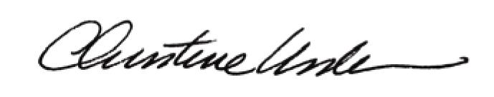

By:

Date of Meeting: November 21, 2016 Title: Historic Officer

